DAF Digital Maturity Guide
We must be able to account for the interactive nature of competition and continuously assess ourselves relative to our adversaries’ adaptations. Capabilities must be conceived, developed, and fielded inside competitors’ fielding timelines—knowing we will need to adapt and adjust over time.¹
– Gen Charles Q. Brown, Jr., Air Force Chief of Staff
The Department of the Air Force (DAF) will lose technological advantage over its adversaries without drastic changes in the acquisition process, according to Dr. Roper's Digital Acquisition Vision^{2,3}, the DoD Digital Engineering (DE) Strategy⁴, and Chief of Staff of the Air Force’s Accelerate Change or Lose paper¹. To avoid delivering yesterday’s technology to tomorrow’s fight, we must improve how we develop, deliver, support, and sustain war-winning capabilities, not just the capabilities themselves. DE is defined as “an integrated digital approach that uses authoritative sources of system data and models as a continuum across disciplines to support lifecycle activities from concept through disposal" (DAU). According to the DE Strategy⁴:
Digital engineering will require new methods, processes, and tools, which will change the way the engineering community operates; however, this shift extends beyond the engineering community with an impact on the research, requirements, acquisition, test, cost, sustainment, and intelligence communities. The digital transformation offers similar positive changes for business operations including acquisition practices, legal requirements, and contracted activities.
The DE Strategy outlines five strategic goals:
- Formalize development, integration, and use of models
- Provide an authoritative source of truth
- Incorporate technological innovation
- Establish infrastructure and environments
- Transform culture and workforce
The expected direct benefits of a comprehensive strategy include:
- Informed decision making and greater insight through increased transparency
- Enhanced communication
- Increased understanding for greater flexibility/adaptability in design
- Increased confidence that the capability will perform as expected
- Increased efficiency in engineering and acquisition practices

Assessing Digital Maturity

The Digital Maturity Assessment focuses on quantifying digital engineering and management capabilities. The DAF has leveraged the International Council on Systems Engineering (INCOSE) model-based systems engineering (MBSE) Capability Matrix⁵, which has been used and vetted in industry. Comprised of three equally important steps: Pre-Assessment, Assessment, and Post-Assessment; the process baselines current digital maturity and aids in establishing target states on a scale of 0-4. The identified gaps between target and baseline states is a mechanism to prioritize and guide actions related to digital transformation. When assessing, it is important to note that not every program/organization will have the same end-state goals nor value-based justification for advancing their current state, and thus should not be directly compared to other programs/organizations. This is an important distinction from Technical Readiness Assessments (TRAs) and Manufacturing Readiness Assessments (MRAs), where maturation and risk management implies maxing out the scale.

Programs/organizations must also realize that depending upon their current state of digital competencies, assessment priorities will shift, specifically with respect to tools and data management. For example, if personnel do not have access to the tools necessary to effectively execute a digital strategy, they will not be successful. Likewise, if there has not been a strategy to proactively manage data (centralized access and revision control at a minimum), progress will be limited until these fundamental prerequisites to digital transformation have been addressed.

This assessment process also enables each program/organization to identify and prioritize the metric components that offer the most value to their organization, and communicate that relative importance in post-assessment planning of initiatives.

Digital Maturity Metrics
The following section defines the relationships between categories, metrics, and components. Components are the 19 factors the assessment process quantifies, and then subsequently aggregates to achieve 7 overall metrics for a program/organization. This relationship can be seen in Table 1.

Table 1: Categories, Metrics, and Components
Category | Metric | Component
Infrastructure | Model Environment | Tool Access and Governance
 |  | Interoperability
 | Collaboration | Capability
 |  | Security
Modeling / Analysis | Quality | Authoritative Sources of Truth (ASOT)
 |  | Metrics
 |  | Model-Based Verification and Validation (V&V)
Process / Policy | Model Management | Digital Management Strategy
 |  | Model-Based Systems Engineering
 |  | Configuration Management
 |  | Process Verification and Validation (V&V)
 | Data Management | Innovative Technical Processes
 |  | Technical Management Processes
 |  | Analysis, User Interface (UI) and Visualization
Workforce / Culture | Workforce | Digital User Skills
 |  | Common Digital Understanding
 | Adoption | Digital Artifact Use
 |  | Reference Architecture Implementation
 |  | Milestone, Program, and Technical Reviews; Audits

The digital maturity metrics are grouped in four categories: Infrastructure, Modeling/Analysis, Process/Policy, and Workforce/Culture. The outline below, organized by categories, provides descriptions for each of the 7 metrics and their respective components.
- Infrastructure
  - Model Environment: the ability to conduct digital operations based on available hardware and software configurations
    - Access and Governance: Users have appropriately controlled access to digital tools necessary for processes across the lifecycle. Tool access and governance policies and procedures are defined, understood, and uniformly applied.
    - Interoperability: Tools are interoperable and utilized for distributed engineering and enterprise decision-making. Data is interchangeable among, and independent from, tools.
  - Collaboration: an integrated digital environment* that is standardized, secure, and enabling
    - Capability: On-line, real-time collaboration amongst distributed teams (government and/or industry) actively interacting via a shared digital environment.
    - Security: Models and data across the enterprise are secured, monitored, and controlled. Applicable Intellectual Property (IP) policies in place. All necessary classification levels defined by the program are supported.
*NB: An “integrated digital environment” refers to capability, not a specific software or digital environment.

- Modeling / Analysis
  - Quality: the ability to make informed decisions from model outputs and data, and understand the associated risk and uncertainty
    - Authoritative Sources of Truth (ASOT): Model-based definitions are utilized and maintained. Digital threads and digital twins with defined data architectures are established. (Conformance to VAULT principles – Visible, Accessible, Understandable, Linked, and Trustworthy)
    - Metrics: Model metrics are well known, understood, appropriate, and systematically applied.
    - Model-Based Verification and Validation (V&V): Model development processes have been established that include styles and standards. Model-based V&V procedures and programs have been implemented.

- Process / Policy
  - Model Management: robustness of internal digital processes and operations, and the ability to seamlessly leverage contracted expertise
    - Digital Management Strategy: Digital artifacts, tools, and automation are appropriate and used consistently to inform engineering, program management, logistics, maintenance, etc. across the enterprise. Digital tools support business processes and expedite execution.
    - Model-Based Systems Engineering (MBSE): Consistent approach to integrating system models in the enterprise is driven by best practices and style guides.
    - Configuration Management: Configuration management is uniformly applied and actively maintained for all models and data in the enterprise.
    - Process Verification and Validation (V&V): Processes have been established, best practices utilized, and standard V&V procedures and programs are automated for models and data across the enterprise.

  - Data Management: internal processes/operations and contractor interchanges ensure the ASOT is defined, utilized, and maintained
    - Innovative Technical Processes: Digital artifacts and digital twins drive lifecycle decision making through the utilization of digital threads.
    - Technical Management Processes: Technical data and metadata conform to a common data architecture and are easily searchable, revisioned, controlled, and governed across the enterprise. Automation and data reuse is proactively supported.
    - Analysis, User Interface (UI) and Visualization: UI supports interrogation of ASOT and provides visualizations to inform personnel across the enterprise. UI and visualization tools support business and engineering analyses, and automation.

- Workforce / Culture
  - Workforce: how well trained and competent the workforce is for digital operations
    - Digital User Skills: Robust training, driven by a training strategy, is in place. Personnel know when and how to utilize modelers, whether modelers are resident in the same organization, and share Government resources across multiple organizations or contracted expertise. Modeling methodologies and data management are reviewed by experts for conformance and continuous improvement.
    - Common Digital Understanding: Authoritative lexicons and creditable sources are consistently utilized and referenced across the lifecycle/enterprise (i.e. incorporate accepted community/industry standards) to provide a common, digital understanding.
  - Adoption: a measure of culture change within the workforce
    - Digital Artifact Use: Enterprise decision making is based on digital artifacts and data. Consistent institutional approach and continual improvement is driven by policy, practices, and automation.
    - Reference Architecture Implementation: Government approved, domain specific reference architectures are sufficiently defined and utilized across the enterprise.
    - Milestone, Program, and Technical Reviews; Audits: Enterprise organizations coordinate on common review criteria application and tailoring, and the use of digital artifacts as deliverables. Models automatically record acceptance through frequent reviews of model content/data to allow stakeholders to ensure that the review is complete based on criteria.

Pre-Assessment
Prior to a self-assessment, the leadership of the self-assessment team should make, communicate, and document several decisions/activities:
- Determine the balance of participants in the assessment. What types of engineers, technical staff, management, logistics, contracting, finance, etc. should be included and in what proportion of total respondents?
- Ensure all participants review the cited strategic documents in this guide, and understand related concepts: digital engineering and management, authoritative source of truth, Digital Twin, Digital Thread, etc. 4
- Define the component relative weights (column O of the assessment spreadsheet), 1-10 with 10 being most important.
  - If the leadership of the self-assessment decides to ignore a component, the weight should be set to zero.
  - Programs/organizations that do not have appropriate access to tools and/or data management strategies are suggested to weight these categories highly, as deficiencies in these areas will limit growth in other areas.
  - If desired, relative weights can be applied later so as to not influence individuals’ scoring in the assessment process.
- Define "enterprise" (e.g. program office, program office plus prime contractor, etc.) and "organization" (e.g. directorate, division, etc.) for the scope of this assessment and communicate these assumptions to all participants. It is important that these assumptions/constraints are clearly communicated, consistently interpreted, and documented.
- Lead a collaborative, group meeting:
  - Review pertinent organizational documents, observations of digital engineering and management in practice, and/or interviews of subject matter experts or pathfinders to level-set group perspectives.
  - Determine digital needs, benefits, goals, and objectives of the program/organization to be assessed (consider the entire lifecycle and ROI implications).
  - Align the digital maturity components to the objectives above, and determine how they support the digital goals of the program/organization.
- Review the group meeting results (i.e. goals and objectives) and determine the most appropriate target state for each of the 19 components – enter into column L of the assessment spreadsheet. The target states can be whole numbers (level 0-4) that best represent the collection of opinions that leadership agrees at a future state (3-5 years in the future). NB: This is the recommended approach, but deviations regarding who and when weighting factors are applied, whole numbers or fractions on the target state, or requesting participants to assign their opinion of the target state are at the discretion of the leadership team of the self-assessment. Document all process deviations for future reassessments and quantifying progress over time.

Assessment
After the participants have completed the self-assessments, the following steps will help ensure representative results and set up insightful analyses:
- Track the number of respondents and what role they play in the organization. Ensure that the desired diversity across functional areas of respondents was achieved.
- Average the numeric (levels 0-4) responses from all who responded (not all respondents have to submit all 19). This will result in 19 averaged baseline component states.
- Input the average for each of the 19 components into column J of the assessment spreadsheet.
- Review assessment feedback for patterns associated with roles and responsibilities. (e.g. do contracting respondents feel the current state of Workforce Capability is substantially lower than systems engineers? Or, are these responses consistent? Analyzing respondent groups can provide organizational insight.)
- The following Figures (1 & 2) display the baseline and target, component and metric, outputs from two tabs in the Maturity Assessment spreadsheet.

Figure 1: Notional Component Output Showing Digital Maturation Gap
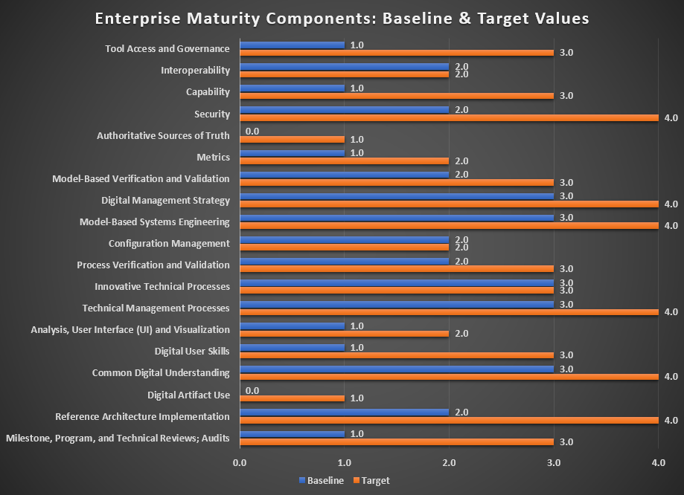
In Figures 1 & 2, an example of the Maturity Assessment output can be seen. The orange bars represent the target maturity levels for each component/metric as identified by program/organization leadership. The blue bars represent the self-assessed baseline state of each component/metric as averaged by the program/organization.

Figure 2: Notional Metric Output Showing Digital Maturation Gap
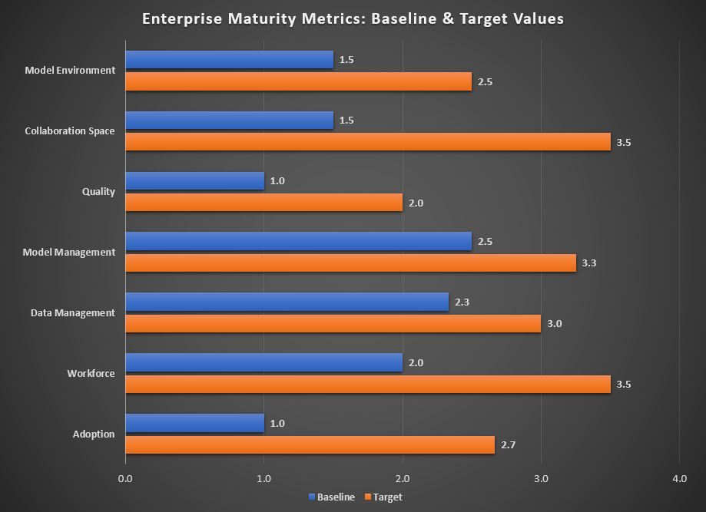

Post-Assessment & Next Steps
Once completed and compiled, develop a list of potential digital transformation focused improvement initiatives to close the gap between the baseline and desired target states as determined through the assessment. The next steps will vary depending upon characteristics of each program/organization, but could include:
- Designating a digital focal point within the organization (e.g. Chief Engineer, Program Manager, Director of Engineering, etc.). This will ensure a central point of contact for tools, training, and infrastructure needs, enable consistent implementation and coordination, and sharing of lessons learned and collaboration across the DAF.
- Comparing maturation gaps of each metric, including the weighted results as seen in Figure 3, and building a strategy to prioritize and address potential activities to decrease these gaps. This will likely require analyses that drill down to or past the component level. Determining the root cause of the gap will often require targeted interchanges/workshops to reflect on digital needs, benefits, goals, and objectives, and result in specific digital maturation plans.

Figure 3: Notional Relative Importance Given Weighting Factors
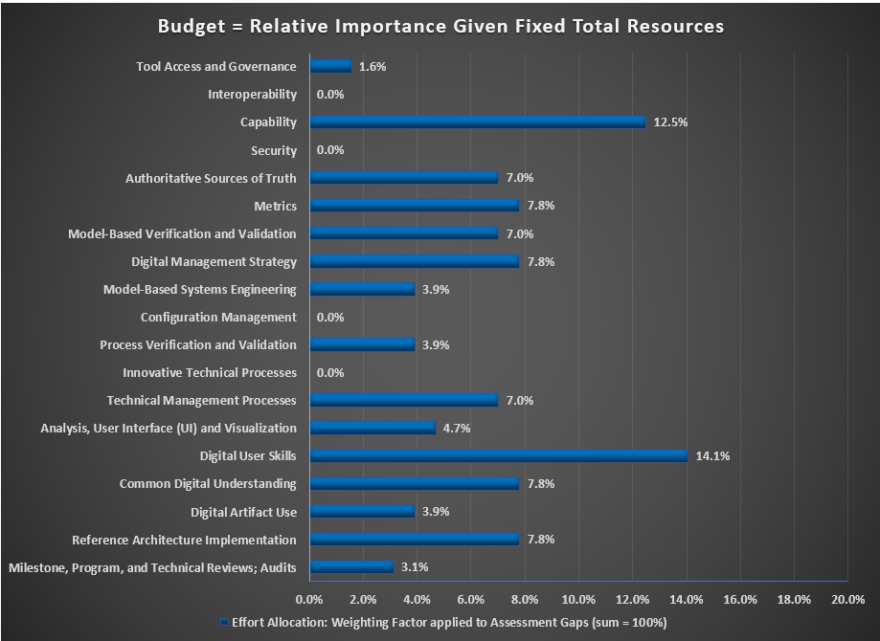

- Comparing similar programs or organizations. A peer-level comparison of common magnitude gaps or target states can lead to resource leveraging/partnering for improvement initiatives. Senior leader perspective on common magnitude gaps or target states can provide insight on systematic issues. NB: Baseline and target sates are tied to program/organization specific goals, objectives, and available resources; thus, detailed comparisons between program/organization baseline values are not always relevant.
- Pursuing pointed strategic initiatives versus attempting to implement multiple initiatives across many components at once. Figure 4 is an example from a pathfinder program office’s effort to plan Digital Maturity increases through strategic investments and process changes (NB: this is a staged approach and the colors of the initiatives correlate to their target states over the near/mid-term).

Figure 4: High-Level Example of Digital Maturation Planning
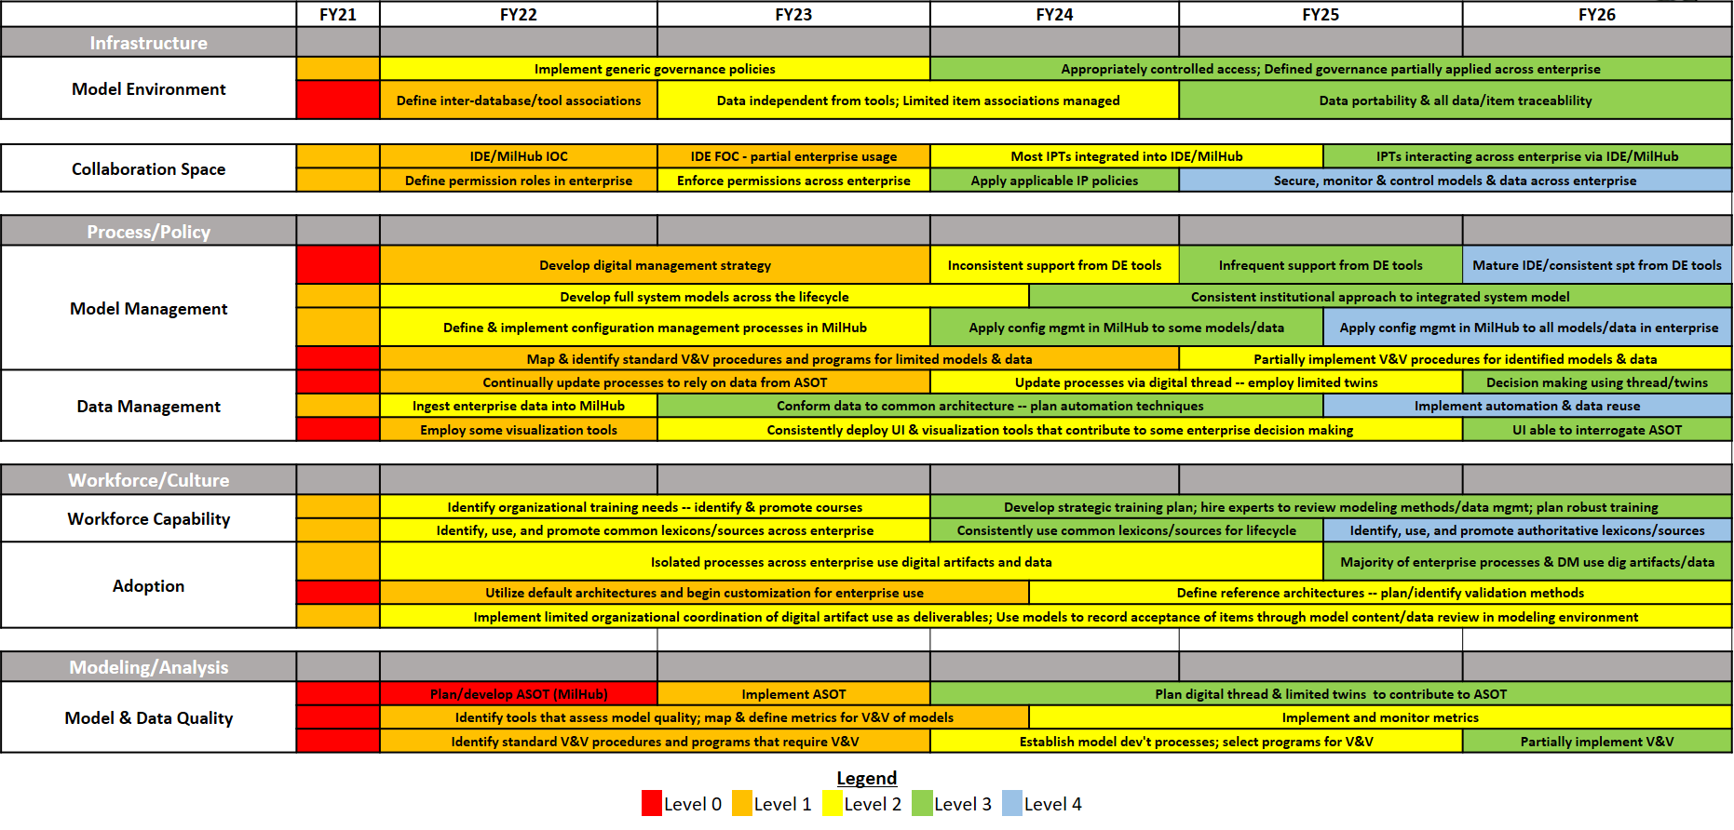
- Annually reassessing digital maturity with up-to-date digital needs, benefits, goals, and objectives for tracking progress over time, quantifying benefits of improvement initiatives, and sharing best practices.

References
- 2020 Chief of Staff of the Air Force’s Accelerate Change or Lose - https://www.af.mil/Portals/1/documents/csaf/CSAF_22/CSAF_22_Strategic_Approach_Accelerate_Change_or_Lose_31_Aug_2020.pdf
- 2020 SAF/AQ Digital Acquisition Vision - https://software.af.mil/wp-content/uploads/2020/10/There-Is-No-Spoon-Digital-Acquisition-7-Oct-2020-digital-version.pdf
- 2021 SAF/AQ Digital Acquisition Vision - https://www.af.mil/Portals/1/documents/2021SAF/01_Jan/Bending_the_Spoon.pdf
- 2018 DoD Digital Engineering Strategy - https://ac.cto.mil/wp-content/uploads/2019/06/2018-Digital-Engineering-Strategy_Approved_PrintVersion.pdf
- INCOSE MBSE Capability Matrix
https://aerospace.org/story/incose-model-based-capabilities-matrix

